Digital Signal Processing: Speaker Detection Project
By: Jacob Moore, Hermena Mikhael, Gabe Everett
Date: 4/21/26

Abstract
This project documents a speaker detection system using machine learning classification. Audio data was collected from two groups: nominal users (authorized speakers) and nonnominal (intruders). Each audio sample was segmented into overlapping 30 ms windows, and Mel-Frequency Cepstral Coefficients (MFCCs) were taken to represent the spectral characteristics of speech signals. These features were used to train a K-Nearest Neighbor (KNN) classifier which was applied to improve classification. A validation process was implemented to optimize both the number of neighbors (k) and the decision threshold. Two threshold search stages (coarse and fine) were used to find a confidence threshold of 0.4368. The trained classifier achieved 96.43% accuracy during validation. Final testing on unseen data yielded 96.4% accuracy for both nominal and intruder detection, showcasing the effectiveness of MFCC in combination with KNN classification. The system also maintained efficient computing performance, completing the full process in approximately 105 seconds. These results indicate that the proposed approach is a reliable and feasible solution for speaker detection applications.

Introduction
Audio recognition is widely used in applications for security, authentication, and human-virtual interaction. The ability to distinguish between authorized and unauthorized speakers enables systems such as voice-controlled devices, access control systems, and surveillance technologies to operate more securely and efficiently.
Speech signals are complex and vary over time due to differences in pronunciation, pitch, and external conditions. To address this, different extraction techniques are used to capture the most relevant characteristics of speech while ignoring unwanted variables. One of the most widely used feature representations is the Mel-Frequency Cepstral Coefficient (MFCC), which models human audio perception and provides a representation of the speech spectrum.
In this project, a speaker detection system is developed using MFCC extraction and a K-Nearest Neighbor (KNN) classifier. The system processes audio signals in short overlapping windows to capture time behavior and uses distance-based classification to group similar speech patterns. Moreover, validation techniques are employed to optimize model parameters such as the number of neighbors and classification thresholds. The goal of this work is to design a robust and efficient system capable of accurately identifying known speakers while rejecting unknown individuals.

Methodology

Data collection
The aggregation of data was divided into two sections, the nominal and nonnominal (referred as Intruder). The nominal set consisted of 10 members (4 Female, 6 Male), the Intruder set consisted of 4 members (2 Female, 2 Male). Refer to appendix A for a table of each user, their grouping (Nominal or Intruder), and the number of samples taken per process. This project went through three different processes Training, Validation, and Testing. The nominal group did every process while the Intruder group were only used in Validation and Testing. In the Training process 3 samples were taken per user, while in the Validation and Testing 2 samples were taken per user. With the total amount of samples taken for the nominal group being 7 while 4 samples were taken for the Intruder group.

Input Processing
For speaker recognition, features must be extracted from each audio file. This is performed in the extractFeatures.m file (refer to appendix B). The main features to be extracted are the Mel-Frequency Cepstral Coefficients (MFCC), which describe the short-term power spectrum of a sound. Pitch is avoided, as it can fluctuate throughout the sample, and many people may speak at the same frequency.
Extracting a feature once from an entire file is ineffective, as the data in said file changes throughout. Instead, each file is divided into small 30ms windows, which may be referred to as data points throughout this report. These are defined using the Hanning window format, which ensures the amplitude of the signal at the edges is zero, and the center is one. Figure 1 shows this response. As the amplitude is zero at the edges, these windows are given a 50% overlap to ensure no data is lost. Each of these windows is labeled to match its parent file to keep them organized.
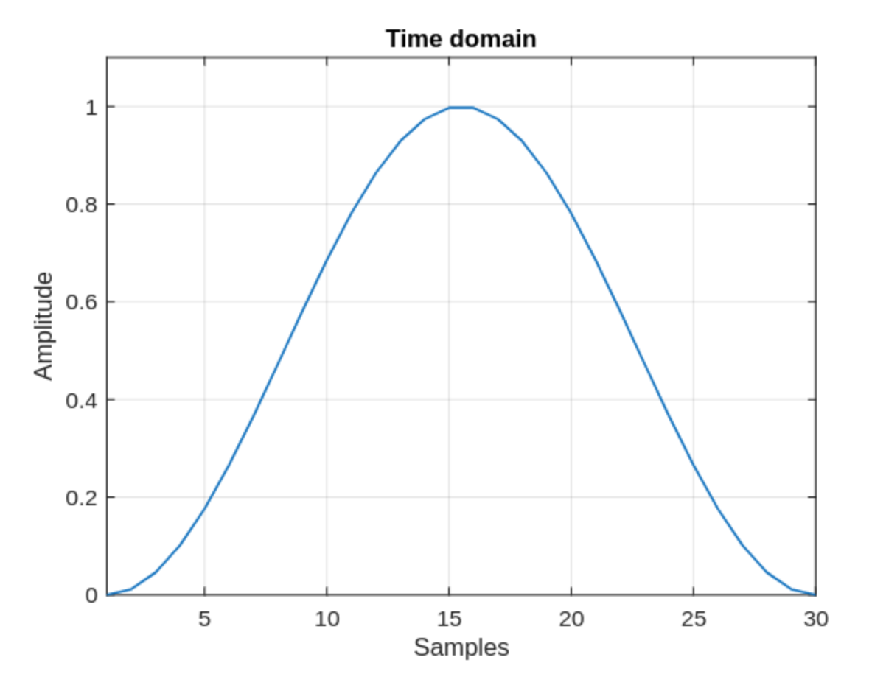

Figure 1: Hanning window describing amplitude over 30ms.

Training Algorithm
To allow for speaker recognition, a classifier must be trained, which is done in trainClassifier.m (refer to appendix C). Only nominal speakers are used for this training. The training algorithm used is K-Nearest Neighbor (KNN), in which the training data points are clustered with each other according to their extracted features, hopefully corresponding to their respective speakers. Test data points—or feature-extracted data clustered according to speaker—are then inserted one-by-one, where the k-nearest neighbors are used to classify said input as one of the ten nominal speakers.
The weights of each neighbor on the prediction are defined using the inverse square law, $ω=\frac{1}{d^{2}}$, where the impact of a data point is greatly reduced as its distance from the test data point increases. This ensures that closer, more similar neighbors are prioritized over farther ones. Comparing the number of similar-cluster neighbors over the k-value, a confidence ratio for each related cluster is generated. If this ratio is over a defined threshold, the highest-confidence ratio of speaker is selected, otherwise they are defined as intruders. This is done for every window for a given speaker, after which they are passed through a second cumulative threshold before finally confirming their collective speaker guess.

Validation Algorithm

k-Value Analysis
The validation process first does a sweep through various k-values. Rather than doing a linear sweep, k-values are tested in exponentially spaced intervals $k=2^{n}+1$ where $n=1,⋯,10$. This spacing explores a wide range of k-values without very long computations.
The classifier is trained on the nominal training data with k number of nearest neighborhoods. Then validation—described in the next section—is performed solely on validation data to find the biggest gap between the nominal accuracy $A_{nom}$ and the intruder accuracy $A_{int}$, while finding the smallest standard deviation. This is described in Equation (1).
 | $$Score=\left|A_{nom}-A_{int}\right|$$ | (1)
Smaller k-values provide the greatest mean difference but higher standard deviation, while larger k-values provide smaller standard deviation but tend to overfit. Settling between the two provides a neighboring system that rewards both bigger gaps between nominal and intruder data while also penalizing high variance within each. The k-value with the highest score is used to retrain the classifier, before finally being tested on the test data.

Coarse & Fine Threshold Analysis
To quickly determine the general speaker detection threshold value at which the model is most accurate, a coarse search is used. Thresholds of 0.1–0.9 with step size 0.1 are tested against validation data.
The two thresholds with the highest accuracies are identified and used as bounds for a refined search. Twenty evenly spaced thresholds are then evaluated from these bounds extended by 0.1 for safety cushioning. This setup ensures a more precise threshold for improved accuracy.

Results

Training Process
Training the classifier produces a cluster map of every audio window. These windows are displayed in different colors according to their respective speakers. Displaying the full thirteen MFCC layers on a 2-dimensional plane would be messy; only the first two are used below in Figure 2 to show the clustering effect.
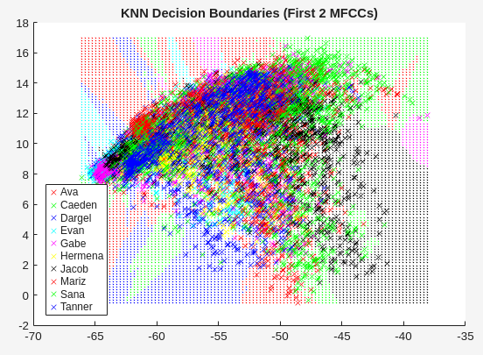

Figure 2: Map of a K-Nearest Neighbor trained classifier clustering nominal data windows.

Validation Process

k-Value Analysis
After calculating the best k-value for the speaker recognition system, each value with its respective accuracy is plotted. Figure 3 on the next page shows this comparison. The best k-value is shown to be 33.
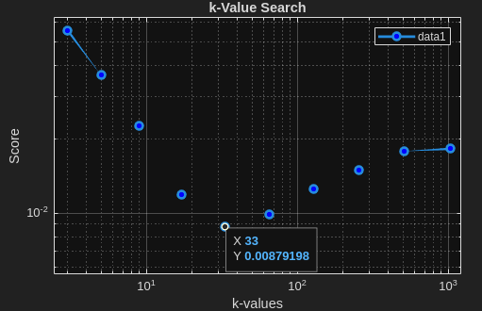

Figure 3: Plot of k-values vs. Accuracy.

Coarse & Fine Threshold
The speaker detection threshold search algorithm tests ratio values 0.1–0.9 with a coarse step size 0.1 for speed. The accuracy is then computed and plotted, which is shown in Figure 4 below.
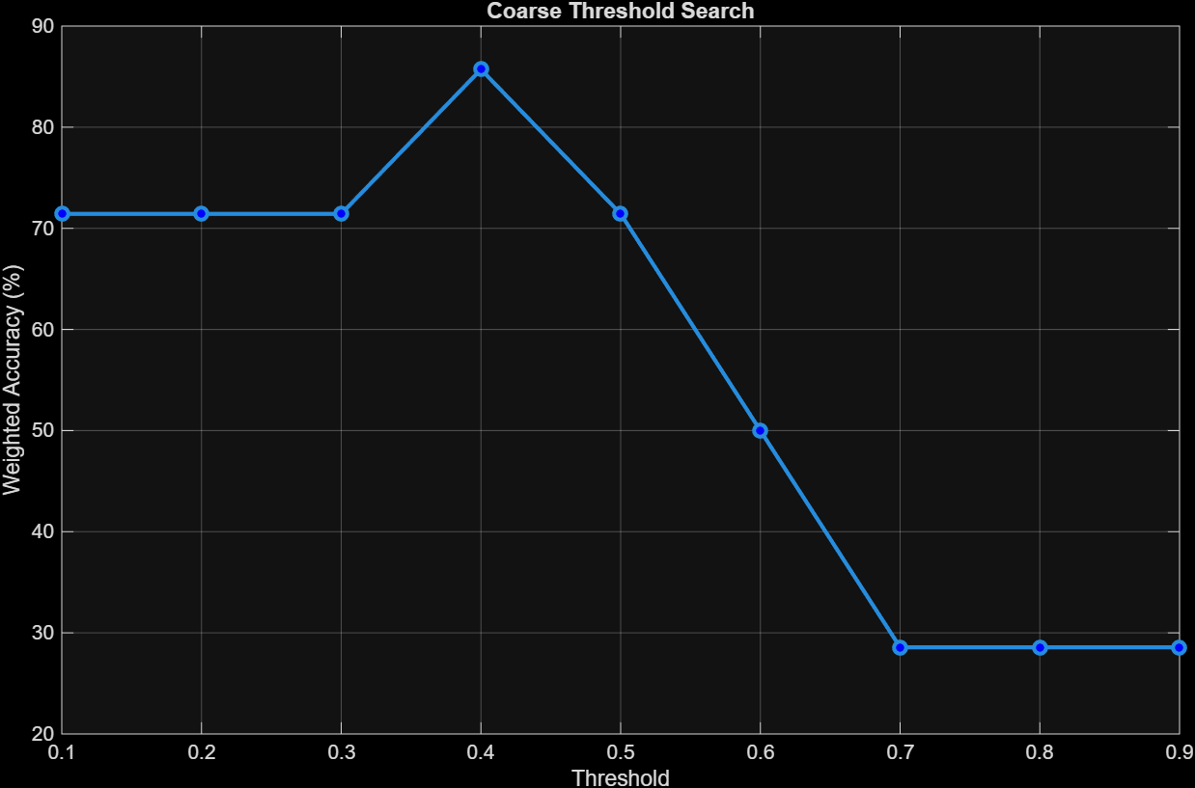

Figure 4: Coarse threshold search accuracy plot ranging from 0.1 to 0.9.
The search algorithm then searches between the two best ratios extended by 0.1, which are 0.1 and 0.5 in this case, in twenty evenly spaced steps. This is a finer, but also a slower algorithm. The results of this step are shown in Figure 5.
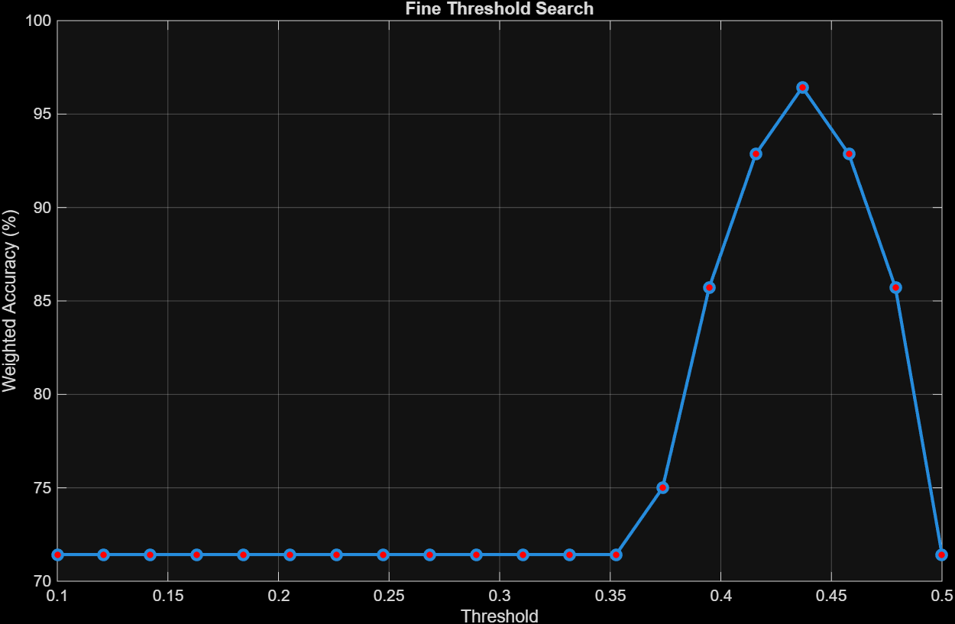

Figure 5: Fine threshold search accuracy plot ranging from 0.1 to 0.5.
The best threshold found was 0.4368. Combined with the best k-value of 33, the classifier has an accuracy of 96.43% against validation data.

Test Process
Following finding the best k-value and speaker recognition threshold, a new, final classifier is trained. Test data is at last accessed and tested against this new classifier. Results show 96.4% accuracy on both nominal and intruder speakers, and a total time from start to finish of ~105 seconds.

Significance
This project demonstrates an effective and practical approach to speaker detection using simple and efficient methods. By combining MFCC extraction with a K-Nearest Neighbor classifier, the system achieves high accuracy without relying on complex models or large datasets. The approach used is very valuable in situations with limited computing resources or small training datasets. The use of windowed extraction and weighted distance metrics further improves reliability by emphasizing relevant speech characteristics and ignoring unwanted variables or outliers. The validation process highlights the importance of analysis in machine learning systems. By optimizing the k-value and detection threshold, the project demonstrates how performance can be significantly improved through careful analysis rather than increasing complexity. Overall, this project provides a good example for how real-world speaker detection systems are modeled and used on a smaller scale.

Appendix A: Table of Users and their samples
User(letter/name) | Email followed by @mail.lipscomb.edu | Nominal  G - Yes  R -No | Training (Nominal only) | Validation  2 each | Test 2 each | Total samples
A - Ava Barrett | abbarrett |  | 3 | 2 | 2 | 7
B - Tanner Ozanich |  |  | 3 | 2 | 2 | 7
C - Caeden Rosen | cwrosen |  | 3 | 2 | 2 | 7
D - Mariz Yosef | myosef2 |  | 3 | 2 | 2 | 7
E - Evan Hughes | emhughes1 |  | 3 | 2 | 2 | 7
F - Ava Dargel | amdargel |  | 3 | 2 | 2 | 7
G - Gabe Everett | greverett |  | 3 | 2 | 2 | 7
H - Hermena Mikhael | hlmikhael |  | 3 | 2 | 2 | 7
I - Sana Ghanem | stghanem |  | 3 | 2 | 2 | 7
J - Jacob Moore | jhmoore3 |  | 3 | 2 | 2 | 7
K - Kat Dunnaway | cmdunnaway |  | 0 | 2 | 2 | 4
L - Anton Salib | aisalib |  | 0 | 2 | 2 | 4
M - Maxx Merlo |  |  | 0 | 2 | 2 | 4
N - Allyanna Wescott | awestcott |  | 0 | 2 | 2 | 4

Appendix B: extractFeatures.m
function [features, labels] = extractFeatures(audioFiles)
% Extract features from audio
fs = 48000; % Confirmed same sample rate
windowLength = round(0.03 * fs); % 30ms analysis window
overlapLength = round(0.015 * fs); % 50 percent overlap (15ms)
aFE = audioFeatureExtractor( ...
Window=hanning(windowLength,"periodic"),...
OverlapLength=overlapLength, ...
SampleRate=fs, ...
mfcc=true, ...
shortTimeEnergy=true, ...
zerocrossrate=true ...
);
fMap = info(aFE); % Referencing this simply produces an index

features = [];
labels = [];
allFeatures = extract(aFE, audioFiles);
allLabels = audioFiles.Labels;
for i = 1:length(allFeatures)
currFeature = allFeatures{i};

% Remove zerocrossrate and shortTimeEnergy
currFeature(:, [fMap.zerocrossrate, fMap.shortTimeEnergy]) = [];

% Label every window
label = repelem(allLabels(i), size(currFeature,1));

% Compile features and labels for all people
features = [features; currFeature];
labels = [labels, label];
end

Appendix C: trainClassifier.m
function classifier = trainFeatures(nomTrainFeatures, nomTrainLabels,k)
% K-nearest algorithm time!!
% {FITCKNN} = {FITClassifierK-NearestNeighbor}

classifier = fitcknn(nomTrainFeatures, nomTrainLabels, ...
Distance="euclidean", ...
NumNeighbors=k, ...
DistanceWeight="squaredinverse", ...
Standardize=true, ... // Normalization
Classnames=unique(nomTrainLabels) ...
);

